|  |  |
| --- | --- |
| RGB | Grayscale |
| (213,80,155) | 128.32 |
| (24, 60, 122) | 56.30 |
| (212, 9, 19) | 70.84 |
| (211, 200, 155) | 198.16 |
| (153, 155, 154) | 154.29 |
| (8, 8, 100) | 18.49 |
| (213, 222, 12) | 195.51 |
| (15, 25, 155) | 36.83 |
| (143, 100, 123) | 115.48 |

Thresholding = 110

G>110 = 1

G<110 = 0

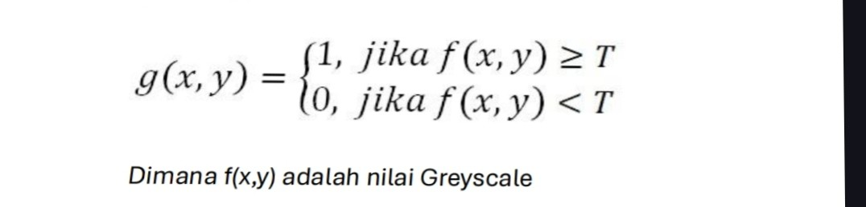

|  |  |
| --- | --- |
| Grayscale | T=110 |
| 128.32 | 1 |
| 56.30 | 0 |
| 70.84 | 0 |
| 198.16 | 1 |
| 154.29 | 1 |
| 18.49 | 0 |
| 195.51 | 1 |
| 36.83 | 0 |
| 115.48 | 1 |

Maka :

|  |  |  |
| --- | --- | --- |
| 1 | 0 | 1 |
| 1 | 1 | 0 |
| 1 | 0 | 1 |